Target Marketing: A Case Study of McDonald's
Student’s Name
Institutional Affiliation
August 22, 2019

Most companies have used target marketing as a key to increasing their sales. Target marketing involves breaking a market into different segments and then concentrating your efforts in one of the segments that consist of the customers whose needs are a close match to what your product or service is offering. Target marketing can be used as a key to the attraction of other new businesses into the market, increasing sales and making the business a success. Target marketing allows the Company to aim their efforts at specific consumer groups, and this makes the promotion, pricing, and the distribution of their products cheaper. Besides, the criteria provide focus to all the marketing activities of the Company. 'McDonald's Company is one of the biggest companies that have been using the target marketing strategies in their operation, and the results from this strategy can be verifiable through the success of this Company.
Since its inception in 1955, the 'McDonald's has been continuously growing and has developed to become the leading foodservice organization. The 'McDonald's is not only renowned for its quick-service restaurants, but it has as well changed the eating habits of the Americans. The Company operates more than 31,000 restaurants that are spread in 119 countries in six continents. The restaurants are run by both the Company and other as franchises but are managed under the same brand and strategies. Despite the intense competition that faces the information eating out the segment, 'McDonald's has been able to attract customers, and it is growing and continuously expanding to other countries. The success of the Company depends on the capability of its quick action on the shifting demographics, taste and preferences, as well as the innovative trends of consumers in the supply chain management.
McDonald's segmentation, targeting and positioning are one of the integrated components of its marketing strategy. Segmentation is the ability of a company to divide a population according to the characteristics they portray. Targeting implies the choice of the specific groups that have been identified from segmentation to sell products to them. Positioning is the selection of the marketing mix that is most suitable for the selected customer in a target segment. 'McDonald's employees an adaptive model of product positioning and as well it is involved in the periodical repositioning of its services as well as products according to segmental changes that occur. The customer target segment serves as the guiding principle for the marketing management of McDonald's in dealing with its marketing mix; product, place, price, promotion, people and process.
McDonald's is a Business to Consumer company that is more oriented to selling its products to its customers and developing a more significant customer base. The use of social media platforms has enabled the Company to target its customers based on the market segments. The Company uses three main types of market segmentation to target its customers, and these are demographic segmentation, psychographic segmentation and geographic segmentation. In demographic segmentation, 'McDonald's has sorted their products according to age, gender, income level, marital status, education, race and religion. Demographic segmentation has become one of the effective ways of target marketing for the Company. McDonald's utilizes the knowledge about her customers to provide products that the customers at all segments are comfortable with. The geographic segmentation involves segmenting the market in terms of its location. McDonald's despite providing its services on an online platform, it has identified the neighborhood of the residence of its customers, and this has enabled it to set more of the franchises in places that they have identified as having more potential customers. The geographical segmentation concept relies on the fact that consumers on a particular geographic area may have specific preferences of some products and services as compared to other consumers on a different segment. The psychographic segmentation divides the market based on the socio-economic class and the preferences in lifestyle. The socio-economic status of the consumers can run from the educated top to the uneducated and the unskilled at the bottom. The McDonald's has utilized this model of segmentation as well in its target marketing strategy to define the products that it has to offer to which population.
Besides, McDonald's uses the lifestyle preference classification model to target its customers. The model classifies customers according to beliefs, values, and interests. For instances, people can be classified as those that prefer an urban lifestyle and those that are suburban lifestyle lovers. The Psychographic segmentation model is based on the premise that people are subjected to making choices about products based on their preferences in lifestyle as well as their socio-economic class.
In the geographical segmentation, McDonald's focuses on the region as either domestic or international, density as either urban or rural and age between the ages of eight and 45 years. In demographic segmentation, as mentioned above, 'McDonald's uses the criterion of gender and focuses on both male and female. It focuses changes in the life cycle as either a bachelor stage where products are made for people not living at home; newly married people, these are young and have no children, and their products are available too; full nest, a family with children. Under demographic, 'McDonald's focuses on occupation and income as well, and it classifies products for the low income and middle-income earners and those for students, employees and professional respectively. In behavioral, 'McDonald's focuses on the degree of loyalty as either hardcore loyal or as switchers. It as well looks the benefits it can gain as either cost benefits of efficiency in time. It further looks at personality and user status as either easy-going and careless of as either potential and regular fast food eater respectively. On psychographic segmentation, McDonald's focuses on social class and lifestyle. In class, it classifies as either lower, working or middle, and in lifestyle in lifestyle, it uses a cross-cultural consumer characterization model for assessing their demands.
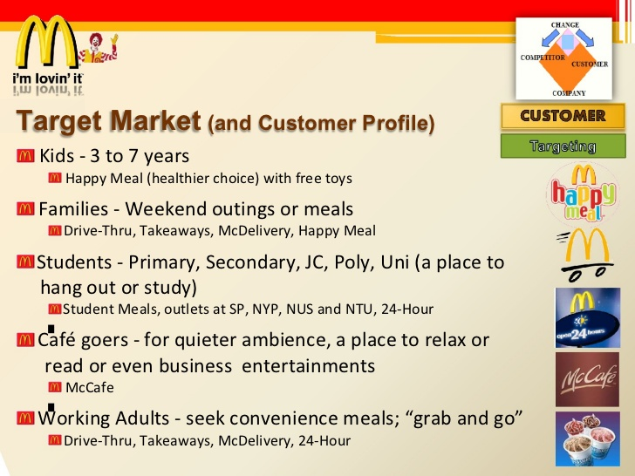
The methods that a company uses in its target marketing have an impact on the promotion of the products as well. The way McDonald's utilizes the target marketing strategies determines its promotion strategies as well. The promotion of its products and services depend on which segment the product is meant. The different segments determine which products are to be promoted and which ones will not. The giving of products to the specific consumers according to their needs has enabled McDonald's to continue its promotional strategies as it is enabled to keep its loyal customers. The identification of the target customer through target marketing enables to give customers what they want. The strategy further enables the company to promote other products to the customers since it knows their tastes and preferences and thus identifying what the customers might prefer is not a problem.
In conclusion, McDonalds is able to identify in its promotion mix which content about certain products should be provided to which customers and which should not because the target marketing has enabled them to define the tastes and preferences of their customers.

References
Al Badi, K. S. (2015). The dimensions of the marketing mix. Journal of Management and Organizational Studies, 2(1), 136-142.
Armstrong, G. M., Kotler, P., Harker, M. J., & Brennan, R. (2018). Marketing: an introduction. Pearson UK.
Bragg, M. A., Roberto, C. A., Harris, J. L., Brownell, K. D., & Elbel, B. (2018). Marketing food and beverages to youth through sports. Journal of Adolescent Health, 62(1), 5-13.
Dudovskiy, J. (2016). McDonalds Segmentation, Targeting and Positioning - Research-Methodology. Retrieved 22 August 2019, from https://research-methodology.net/mcdonalds-segmentation-targeting-and-positioning/
Kaul, D. (2017). A Critical Analysis of Contemporary Marketing. ANVESHAK-International Journal of Management, 6(2), 148-153.
Miksch, L., Nguyen, A., & Schulz, C. (2018). McDonald’s Brand Revitalization Strategy–Big Brands Will Never Die. LBMG Corporate Brand Management and Reputation-Masters Case Series.

